Week 1

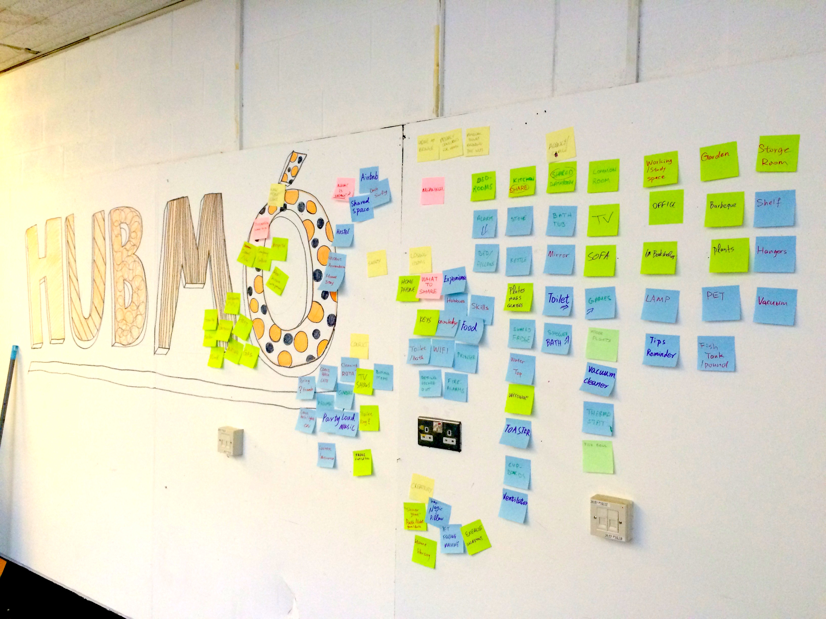
This week started really intense, coming from an interior and environmental design background, creative technology was new and definitely one of the more challenging task I had to undertake as a design student. And professor Jon Rogers and Martin Skelly were great in help getting everybody in the studio on the same page and encourage innovation within a studio cultural space. We have been asked to research and develop a IoT product within the connected homes at the end of this four week module. Having background in interiors I immediately thought about different rooms within the home and different pieces of furnitures within those rooms, how can they interact with each other to improve home quality. As well as brainstorm some of the everyday issues we run in within our homes, and how can we solve this issue by with the help of IoT.

Studio HubMo

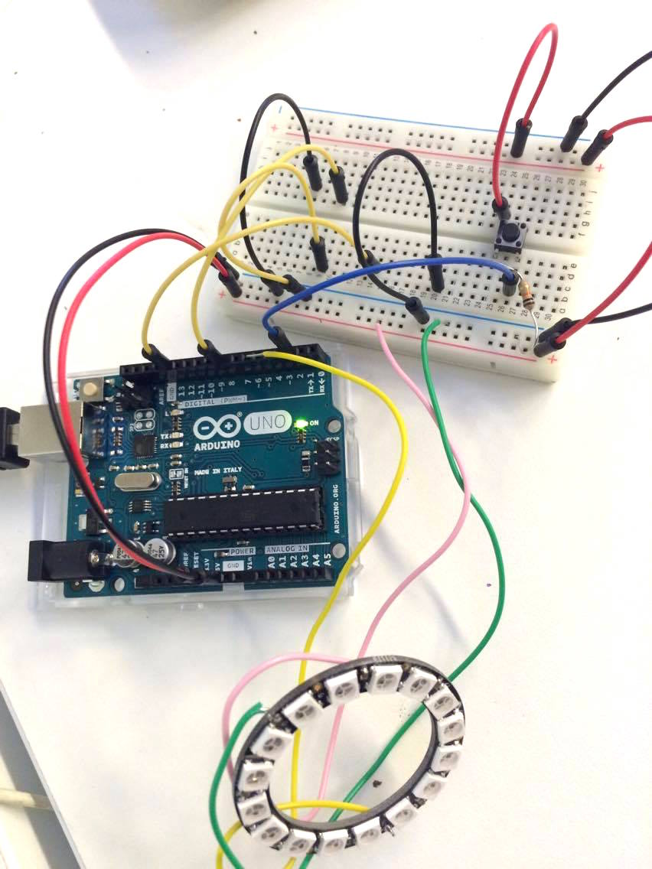
During this week, I came up with 10 different concepts and with the help of two professors I developed 10 different sketches to represent my concepts on Arduino. Use Arduino or rather use Arduino to help develop my concepts was a new theory for me, started with a lot of confusions but once I wrapped my head around it, I realized what a creative and forward way for develop design thinking. Out of this 10 ideas, Idea 2 was the one where I felt most connected personally, and therefore I will be taking this idea forward and develop an end interactive product in the upcoming three weeks.

Idea 2 – Arduino sketch

Having personally experiences in constantly moving globally growing up, I truly understand how hard and important it is to keep in contact and stay connected with loved ones like friends and especially family. Mobile devices with communication apps are seems to be the solution to this problem but also appears to be problematic in this technology-driven 21st century as different age group people's knowledge on technologies are very different and limited, and some find the more technology thrive the more we loose touch in the real world.

My idea is two connected interactive lamps (name yet to be decide) which locates in different parts of the world, by interact with one of the lamp, automatically send a signal to the connected other lamp across the world. A communication interactive tool for the global family and friends, communicating through colours, movements or even noises, use your other senses like touch, smell, hear and more to aim for a more emotional design. There are a few different directions I can go with this project, as it's very personal I would take a more personal approach as to the details of the product relating back to my own family and friends but after speak to a few PHD students, design professors and some further research I feel this isn't just a personal issue anymore, more and more people experience similar situation, especially in the order age group where they craving for this closeness intimacy but find it hard to use the technology appointed. Tackle the social issue of loneliness in this heavy dose of technology era. The upcoming three weeks, will be divided into making scenarios, conduct interviews, analyse feedbacks, learning through making clever prototypes, much like a co-design working processes but with the help of Arduino.
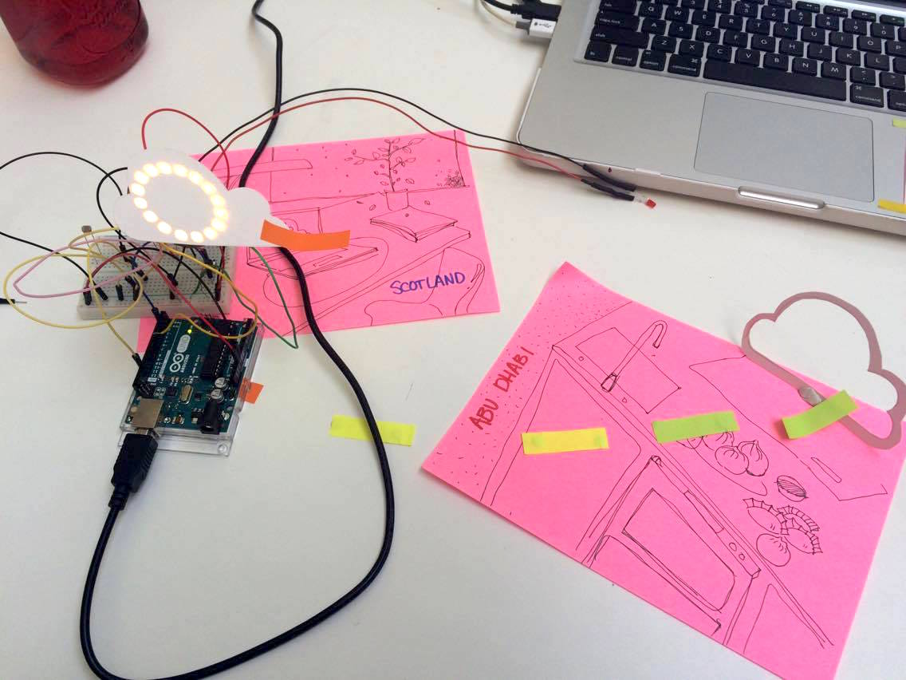

Idea 2 - Emotive prototype

Jane Smith
15/10/2017

